

Application form

PROFFORMANCE – International Higher Education Teacher Award 2024/25
International award for teaching excellence at higher education institutions (HEI) in the European Higher Education Area (EHEA).
Scope of the call
The PROFFORMANCE+ consortium announces the second International Teacher Award in PROFFORMANCE+ partner countries (Austria, Croatia, Czechia, Georgia, Hungary and Serbia).
Aim of the call
The aim of PROFFORMANCE+ project is to promote teaching quality and cooperation, and to support higher education teaching staff in the EHEA. (More information about the project: https://profformance.eu.)
Timescale and deadlines
This call for application will be open until 17.00 CET, 10th December 2024. Applications should be submitted with the approval of the superior of the applicant (e.g. head of department/institution, [vice-]dean, [vice-]rector, etc.) by the above deadline, using the application platform directly on award.profformance.eu.
Eligibility
The call is addressed to individuals or groups of individuals officially involved (with formal agreement) in the teaching process at state recognised/accredited higher education institutions.
The applications should present good practices in accordance with the categories of this call. The practice should have been implemented or being in process with justified outputs exclusively in the following academic years: 2020/21, 2021/22, 2022/23, 2023/24, fall term of 2024/25.
The applications are only valid with the signed nomination form by the institutional superior (e.g. head of department/institution, [vice-]dean, [vice-]rector, etc. of the applicant[s]). See application form. Student nominations are not required, but worth extra points in the evaluation.
Eligible categories:
Applicants should choose 1 main category from the below list:
Category: 1. Student-centred course design
Category: 2. Innovative teaching and learning
Category: 3. Students’ learning assessment
Category: 4. Impact and mission with and for society
AND
Applicants should choose 1 main horizontal priority from the following list:
- Digitalization
- Internationalization
- Inclusion and diversity
- Sustainability

In the application, both the chosen main CATEGORY and the chosen main PRIORITY must be explicitly elaborated.
However, the other 3 priorities can be also presented, if applicable.

Schedule of the application process:

Deadline for applications: 10th December 2024, 17.00 CET
Evaluation period: January–February 2025
Decision and notification of awardees: May 2025
Application step by step

- Please visit the call website at https://award.profformance.eu/ and read carefully
  - The call
  - The application form
  - The evaluation form.
- Register at award.profformance.eu/login.
- Prepare your application on the application platform.
- Get nomination(s) and attach them duly to the application.
  - from your superior - mandatory for an eligible application
  - from your HEI’ student organization - optional, but worth extra points
- Optionally, collect links, materials and upload them to any online space (Dropbox, Google Drive etc.), to complement your application.
- Check if everything is duly filled in, finalize and submit before 10th December 2024, 17.00 CET.
Evaluation criteria
Before applying, please read thoroughly all the materials of the call, especially the evaluation form in Annex 2, to see the main priorities of the call and the evaluation criteria. Please be aware that both the chosen main category and the selected horizontal priority should be referred to in the elaboration of the application. Please be concise, straightforward, emphasise the most important aspects relevant to each question.
The final score will be calculated upon the sum of points given by two independent experts based on the evaluation criteria. The consortium partners Partners | Profformancewill decide the final list of awardees based on the scores and the quantity and quality of the applications.
Awards
The award ceremony is planned to be organized in 2025 at the final event of the PROFFORMANCE project.
The awardees
- will have the opportunity to present their best practices at the final event of the PROFFORMANCE+ project and at various international professional forums,
- will receive the PROFFORMANCE teaching excellence prize with a certificate, and will become members of the PROFFORMANCE professional network. Please note that no financial compensation is offered.
Awardees’ best practices
- will be presented in diverse publications, newsletters, websites including profformance.eu,
- will be available at the PROFFORMANCE “best practices of teaching excellence” database at award.profformance.eu.
Apart from the winners, all eligible applications will be published online in the “PROFFORMANCE teaching excellence database”, once they have been evaluated.
Special conditions
The applicant declares:
- that the good practice
- is not yet in the PROFFORMANCE Teaching Excellence database,
- OR has an added value or an improved content, methodology or augmented quality of relevant characteristics compared to the previous application.
- that in case of a good practice has been implemented in cooperation of different institutions, countries, the applicant
- has an approval from all partners to submit a proposal,
- OR the application is submitted jointly,
- OR a different aspect with recognizable value is presented by the applying partner(s).
- that the applicant(s) indicate(s) in the application
- the institution where the good practice has been elaborated and implemented,
- OR the institution where the team member(s) moved if the good practice has been further developed with recognizable added value.

Annexes
- Application form sample
- Evaluation criteria
- Nomination form of HEI superior
- Nomination form of student representatives (optional)

- Consents

With submission of the application the applicant declares:
- to have read the Call for Proposals with related documents and the Privacy Statement of the PROFFORMANCE+ project and to agree with their content,
- to give consent to the publication of the public content of the application in different platforms handled by the PROFFORMANCE+ consortium (websites, databases, social media, publications, newsletters, events),
- to agree with sharing the good practice (agreed public content) in an online searchable database at the PROFFORMANCE(+) website,
- to present the good practice at the PROFFORMANCE final conference to be held in 2025 in case of selected application and upon availability,
- to be officially involved in teaching at a state-recognized, accredited HEI in one of the eligible countries (Austria, Croatia, Czechia, Georgia, Hungary, Serbia),
- to obtain an approval for applying from one of the designated superiors (e.g. head of department, dean etc.) of the HEI,
- that the presented good practice has been completed after September 2020,
- that he/she will complete the application and provide materials in English,
- that the practice described in the application have been implemented by the applicant or team of his/her colleagues,
- that the application is aligned with all special conditions of the call.

Have you submitted a proposal for the PROFFORMANCE Teacher Award Call in 2021/22?

Yes
No

If yes please give its title from the Teaching Excellence Database (award.profformance.eu)

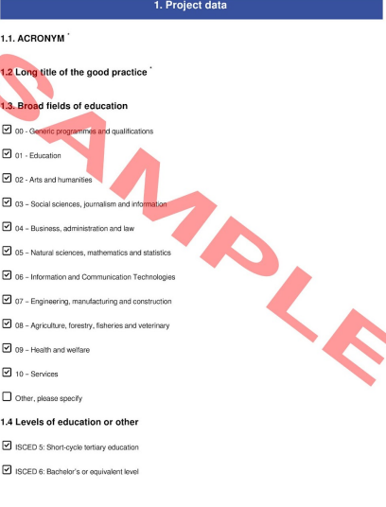
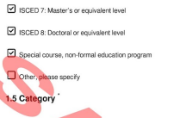

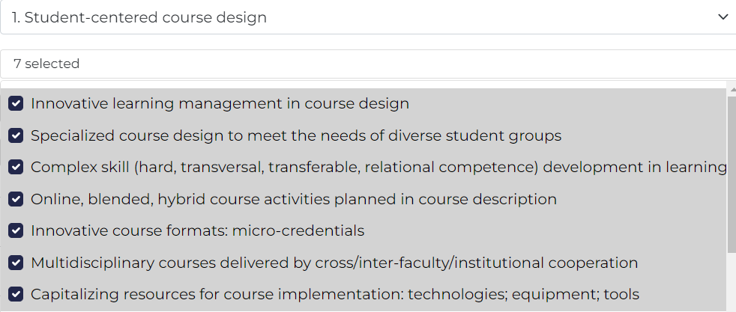

Other elé

Use of Artificial Intelligence in course development, or during the implementation of the course

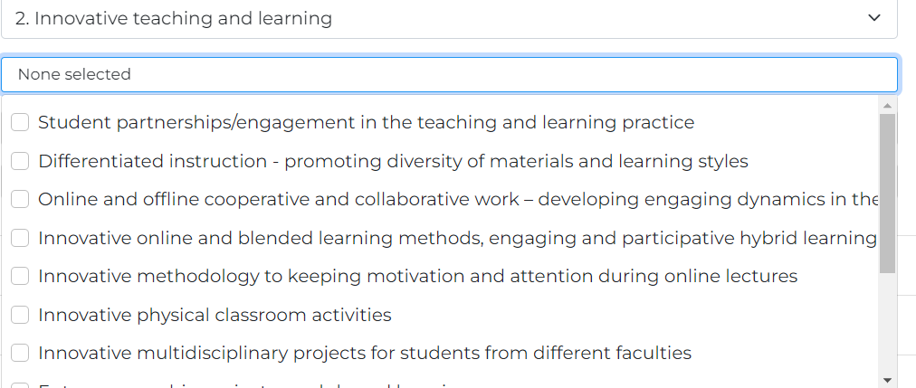
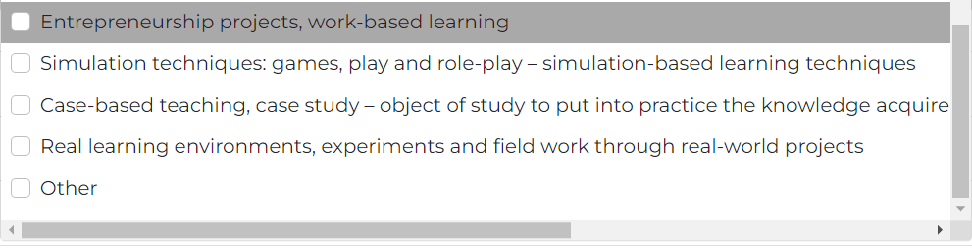
Other elé

Use of Artificial Intelligence during the learning and teaching process

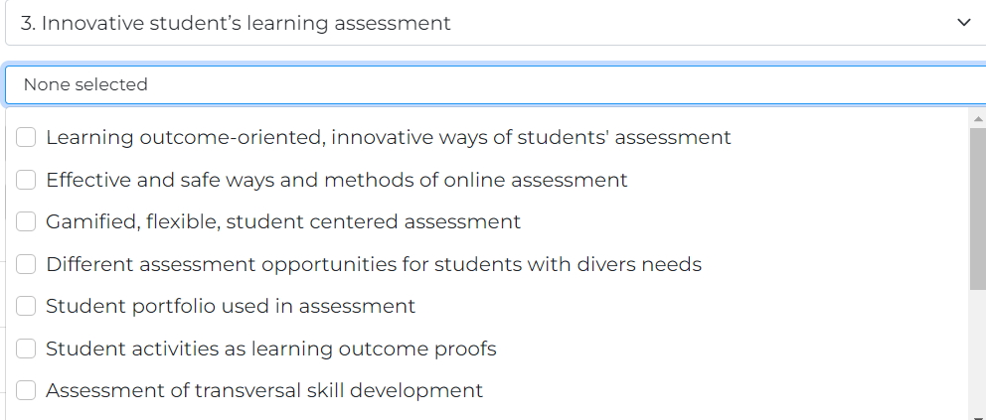

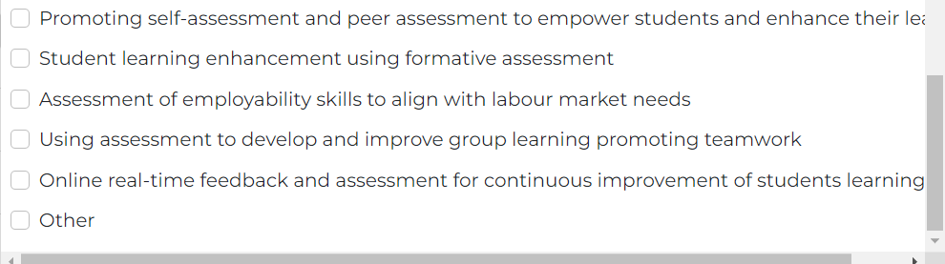

Other elé

Use of Artificial Intelligence in the assessment of students’ learning

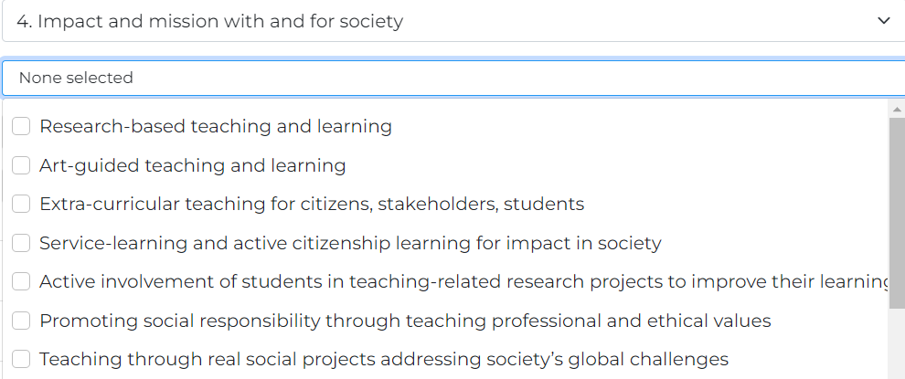

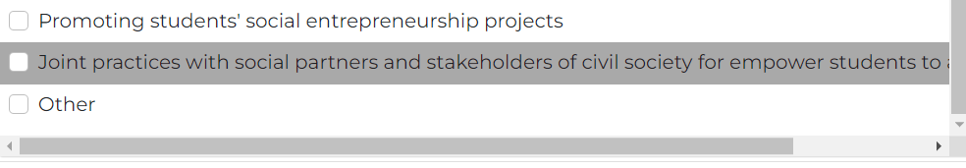
Other elé

Use of Artificial Intelligence for various purposes.

1.6. Main horizontal priority
You can select one main horizontal priority that is most characteristic of your good practice within the chosen category, and in which you have implemented your project that is unique, yet adaptable by other institutions.

The other 3 horizontal priorities may have also an impact on your practice, these can be reflected in point 6. in the Application form

Choose your main horizontal priority now:
Only 1 can be chosen.
- Digitalization
- Internationalization
- Inclusion and diversity
- Sustainability

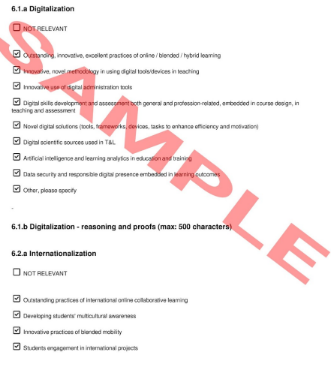
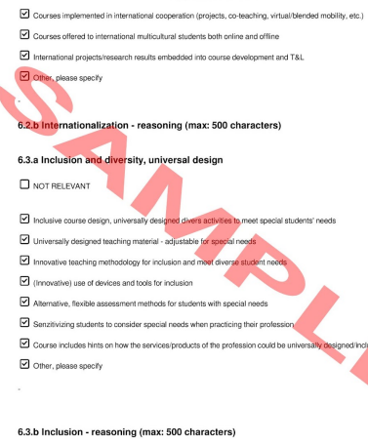
6.4 Sustainability – as it is

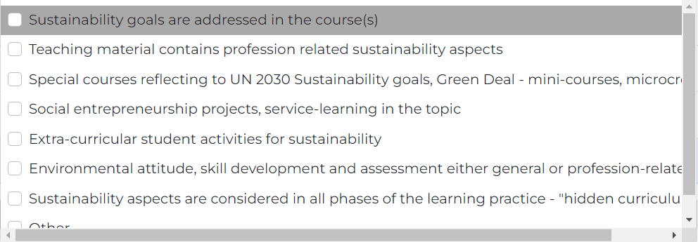

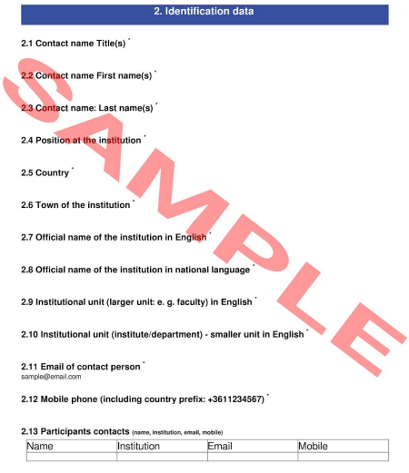

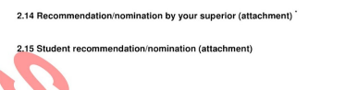

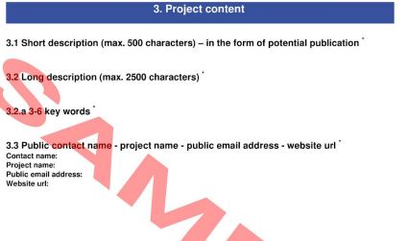

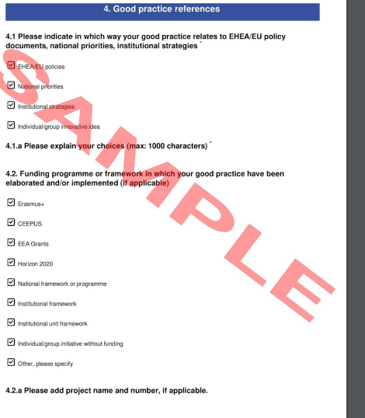

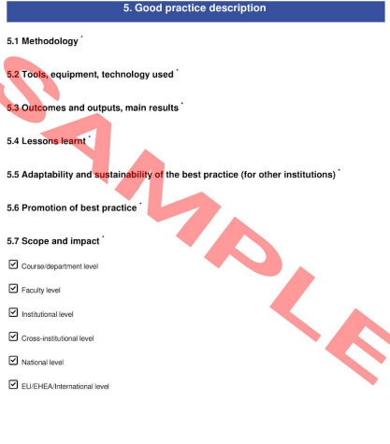

For the chosen main horizontal priority

Digitalization
Please note, that all 4 questions will be evaluated between 0-5 points. The 4 aspects are together worth 0-20 points.
If digitalization is chosen as main horizontal priority - the 4 questions below need to be answered by the applicant:
1. How well did the digital platforms and tools used in the course facilitate content delivery and accessibility ?
2. To what extent did the digitalized course design promote active student engagement and interaction?
3. How effectively did the digitalized course guide students in developing their digital competences, including the safe and ethical use of digital technologies?
4. How effective were the digital methods used for assessing student performance and providing feedback?

Internationalization
Please note, that all 4 questions will be evaluated between 0-5 points. The 4 aspects are together worth 0-20 points.

If internationalization is chosen as main horizontal priority - the 4 questions below need to be answered by the applicant:
- How diverse international/intercultural perspectives and global issues were integrated in course content and delivery?

- In what ways, forms and frameworks did the course promote collaboration and networking among students, teachers and stakeholders from various countries?

- How effectively did the course adapt its teaching strategies to cater to the diverse educational, cultural backgrounds and academic culture of (international) students?

- How did the course contribute to the development of global/international/multicultural competence among students?

Inclusion and diversity, universal design
Please note, that all 4 questions will be evaluated between 0-5 points. The 4 aspect together worth 0-20 points.
If inclusion is chosen as main horizontal priority - the 4 questions below need to be answered by the applicant:

1. To what extent was the course designed and learning organized to be inclusive and diversity-sensitive?

2. How well did the course ensure accessibility and accommodation for students with diverse needs and abilities?
3. How effectively did the course adapt its teaching methods to accommodate the diverse students’ needs?
4. How inclusive were the assessment methods and feedback processes used in the course?

Sustainability

If sustainability is chosen as main horizontal priority - the 4 questions below need to be answered by the applicant:

Please note, that all 4 questions will be evaluated between 0-5 points. The 4 aspect together worth 0-20 points.

- To what extent does your course content explicitly cover topics related to sustainable development and sustainability?
- How well did the applied teaching methodology and learning activities contribute to developing students' competences in sustainability and sustainable development?
- How effectively did the course assess students' understanding and application of sustainability principles?
- To what extent does your course provide opportunities for students to engage with sustainable development challenges (e.g. SDGs or related it to them) through real-world contexts or community partnerships?

For the other 3 horizontal priorities – same as in point 1.6.



